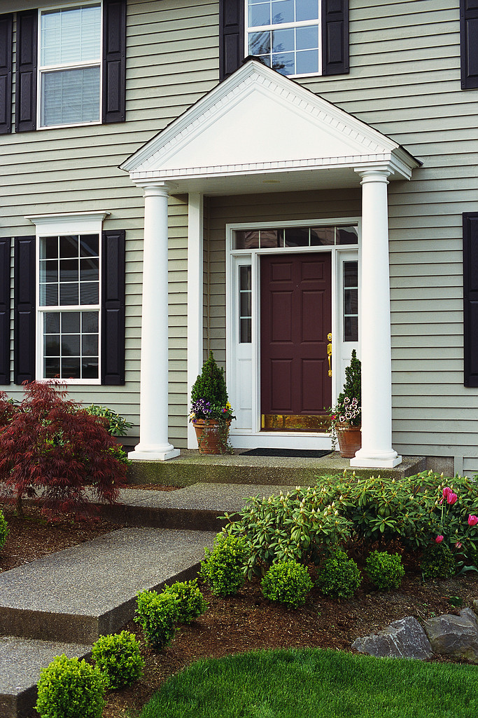
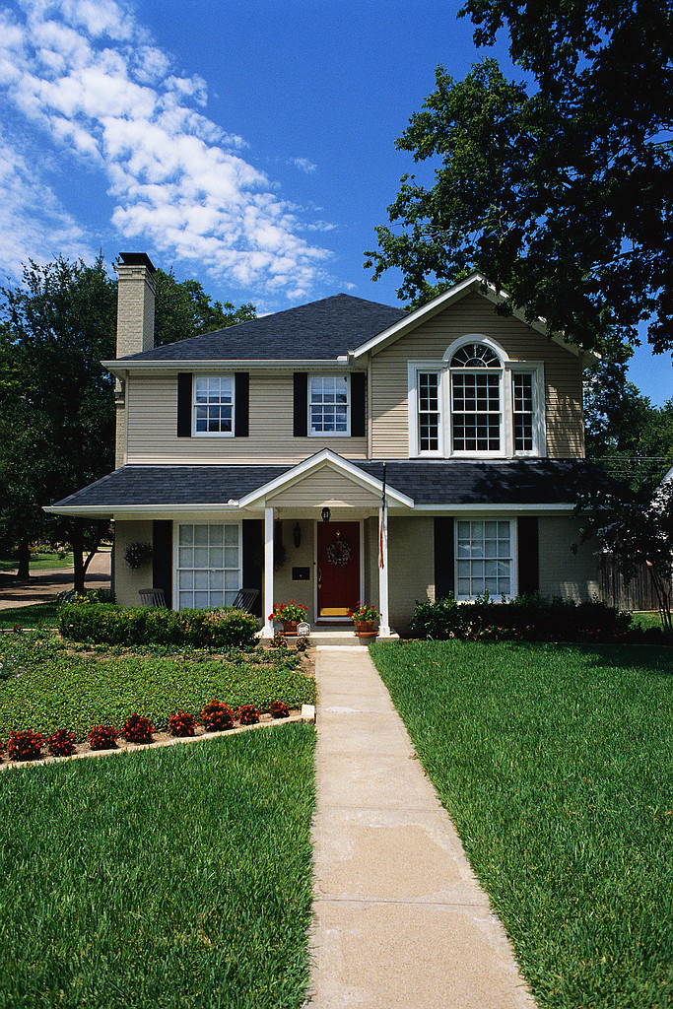

“My Dream House”

You are to describe in detail what you believe would be your “dream house”.

Be sure to include the following:

- Where will your house be located? (city and state, city vs. country, small town vs. large city, etc.)
- What style home would you want? (ranch, 2 bi-level, tri-level, etc.)
- How many rooms in your house? (bedrooms, bathrooms, study, kitchen, dining room, living room, etc.) Describe specific layouts and what would be included in your rooms.
- What else would you like with your home? (Deck, whirlpool, swimming pool, garden, etc.)
- Garage(s)
- And…anything else you would like to include

Once you have described your “dream home”, use the internet to locate your “dream home”. Print out the pictures and description of this home. Attach to your “dream home” description to the front. Use www.realtor.com or another website.

